**Thomas Martin**

**CS-470-18332-M01 Full Stack Development II**

**4-3 Assignment: Lambda and Gateway API**

**Southern New Hampshire University**

**November 23, 2024**

First serverless compute function

Execution results

EchoWithQuery execution results

Screenshot or JSON for the created test event “EchoWithQuery”

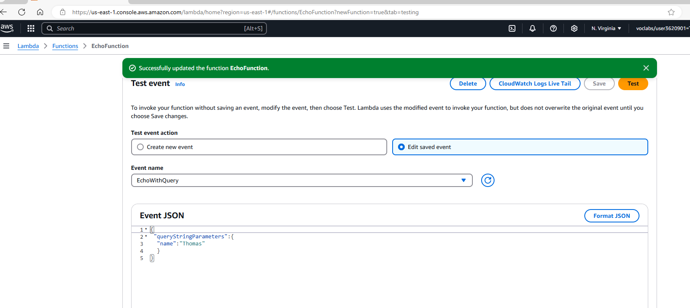

Source code or screenshot for index.js (about 22 lines of code)

